**Director’s Message**

**Valley Fever Center for Excellence**

**July 2024**

Welcome to the Valley Fever Center for Excellence website. Here we try to provide reliable and timely information about coccidioidomycosis, the medical name for Valley fever.

This spring, the Valley Fever Center for Excellence passed two major milestones in helping manage Valley fever. Both are the product of collaboration across the UArizona campus, something that is true for nearly all the projects that are undertaken at the Center. One has an immediate benefit for Arizonans, and the other offers a promise of enormous benefit in the foreseeable future. Neither would be happening if the Valley Fever Center within the College of Medicine-Tucson had not been established, now 28 years ago.

**Happening now: Earlier diagnosis of Valley fever.**

Up and down the “Valley Fever Corridor,” those communities along Interstate 10 from Tucson to Phoenix and especially within Maricopa County, a trend is underway for earlier diagnosis of Valley fever. It would be reasonable to assume that clinicians in this endemic area where Valley fever is so common would frequently be on the lookout for this problem and frequently be testing patients who have suggestive signs and symptoms like pneumonia. That turns out to be wrong. All too frequently persons with the typical symptoms of Valley fever are treated for something else, often as a bacterial infection with antibiotics, sometimes repeatedly. Published studies spanning the last two decades uniformly have demonstrated that patients with pneumonia in primary care clinics, emergency rooms, and urgent care centers across Arizona and Southern California are tested less than 10% of the time for Valley fever, even though recommendations during this time and before from the Infectious Diseases Society of America, other medical societies, and public health agencies have recommended that such persons should be tested routinely. There are several reasons why this situation has been what it is for so long, but one of the biggest is that for physicians and other practitioners who have already learned to do things one way, they must unlearn what they already “know” before they can change to something else which is better. Since many clinicians receive their medical training where Valley fever is rare, they understandably develop patterns of care that do not take Valley fever into consideration. The Valley Fever Center is changing that.

The affiliation of the two UArizona Colleges of Medicine with Banner Health System nine years ago gave the Valley Fever Center an opportunity to address in a large Arizona health care program the under diagnosis of Valley fever. Banner has a system-wide quality improvement program to incorporate best practices into its care of patients. The Valley Fever Center faculty proposed to work within that program to address Valley fever diagnosis in outpatient care. This resulted in a 2018 roll-out of the tools that you can find on the Center’s website today. When we looked across all of Banner’s Arizona programs, we found that less than a third of new Valley fever infections in Banner were diagnosed before the patient was admitted to the hospital, often then by doing the simple tests that are available to patients without being admitted. Most strikingly was the lack of diagnosis within Banner urgent care clinics where less than 2% of all patients with pneumonia were being tested for Valley fever. Once that baseline was established and in collaboration with Banner’s urgent care leadership, we started something new with urgent care clinicians, providing them every three or four months with brief reminders to test pneumonia patients for Valley fever as shown in **Figure 1**. With that simple but repeated reminder program, rates by 2023 increased over ten-fold compared to 2020. As gratifying as that result was, still, less than one in five persons with pneumonia were being tested as was recommended.

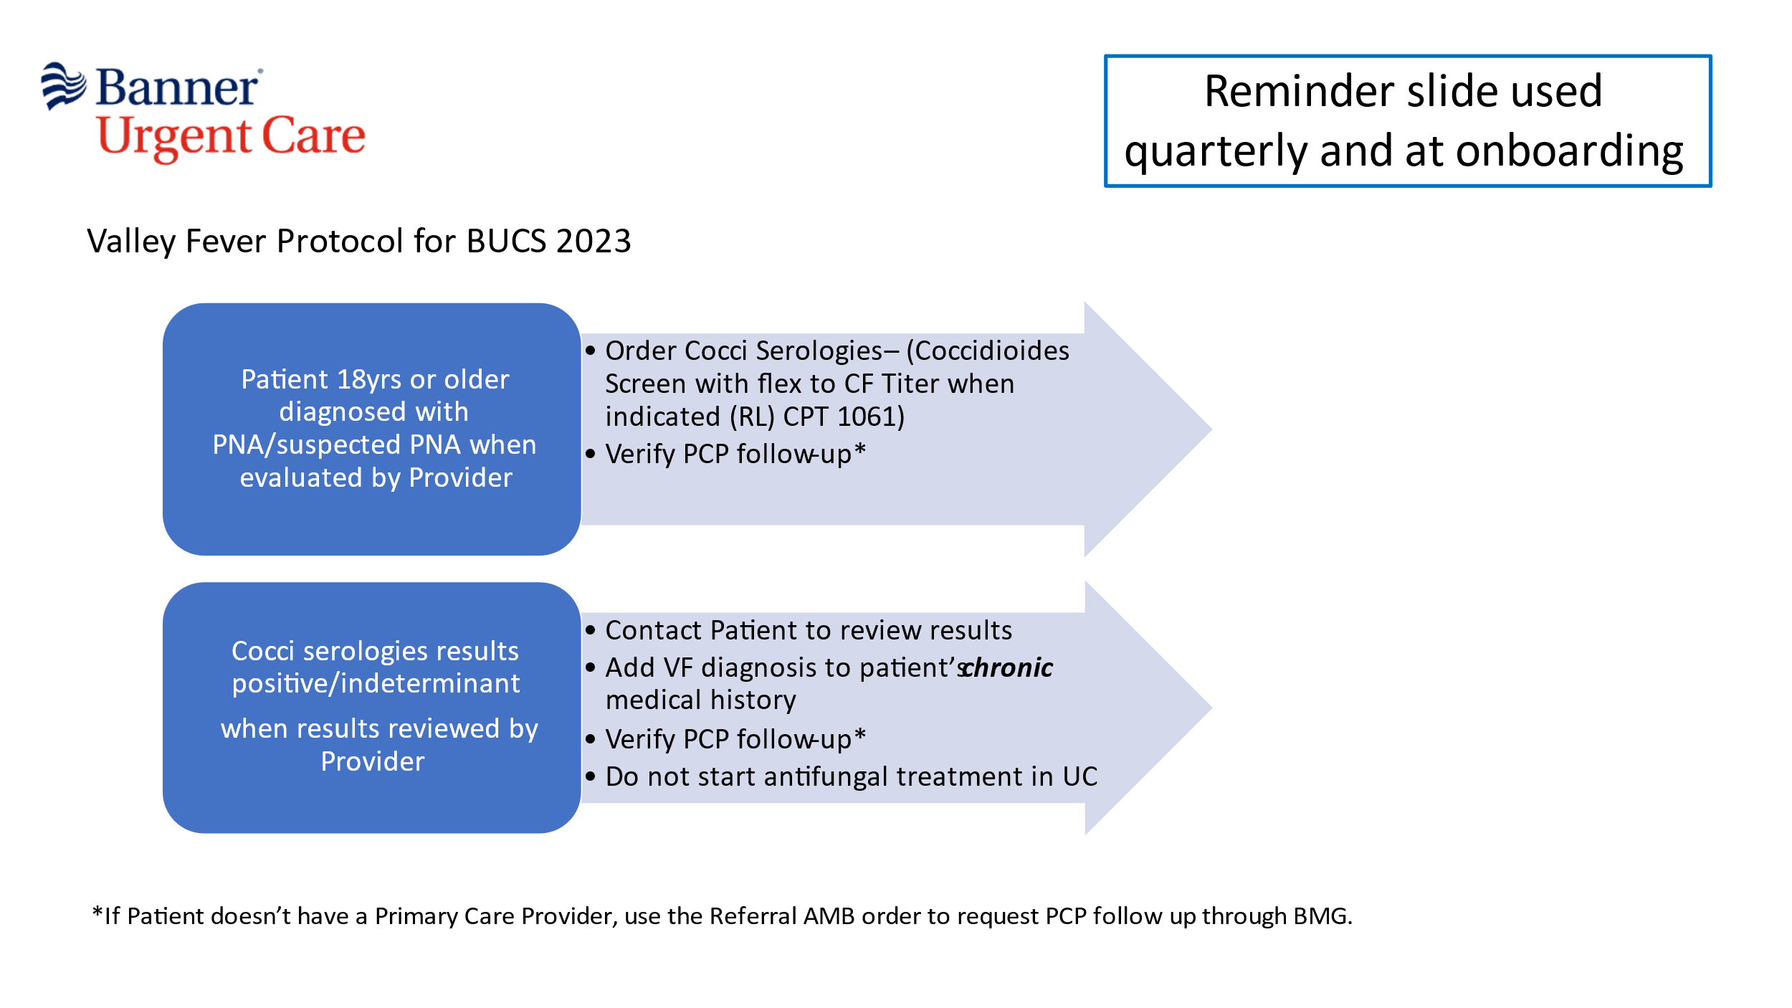**Figure 1**.

To improve things further, again in tandem with Banner, the Valley Fever Center developed a dashboard which assembles actual information from the Banner urgent care clinics themselves to monitor what percentage of persons with pneumonia are being tested for Valley fever. Just as importantly, the dashboard also shows how frequently those tests are positive. This information is updated daily resulting in near real-time information for how much Valley fever disease activity is in the community that urgent care clinics are helping. The dashboard itself is available online to all the urgent care clinicians. Also as trends develop or change, they occasionally receive an email update to highlight those changes. Making this information available to the clinicians, as it is happening, has been very valuable. Testing practices have continued to increase. During this June and the first half of July, rates of testing pneumonia patients for Valley fever have been more than one in three. This program has been widely noticed in the media, especially in Maricopa County where most of the Banner urgent care clinics are situated. It is possible that the leadership shown by the Banner clinics will provide incentive to other urgent care clinics across Arizona to follow suit. Also, because the Arizona Department of Health Services has demonstrated in the past that public awareness increases earlier testing for Valley fever, the Valley Fever Center has put on its website the prevalence of Valley fever as a cause of pneumonia both for the current and previous year (**Figure 2**). The success of our work with Banner urgent care has led to replicating the dashboard program into the 14 Banner emergency departments across Arizona. Overall, this is an excellent example of the Valley Fever Center and Banner Health working together to promote public health surveillance for this disease.

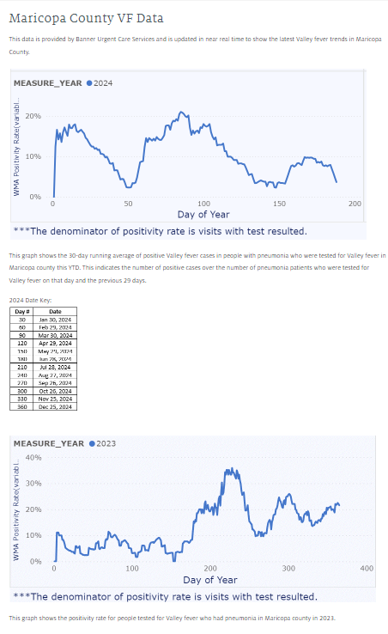



**Figure 2**.

**A promise for the future: Progress toward a human Valley fever vaccine.**

I have written before about the “holy grail” that a vaccine which prevented Valley fever would be. Since the 1950s, there has been ongoing research by many people to make this happen. A decade ago, two Valley Fever Center collaborators, Marc Orbach PhD, Professor and fungal geneticist in UArizona’s department of Plant Sciences, and Lisa Shubitz DVM, a Research Scientist at the Center, discovered that deletion of a specific gene from the Valley fever fungus rendered it unable to make mice sick. Dr. Shubitz then showed that this mutant, when used as a vaccine, protected mice from an otherwise lethal exposure of the normal fungus. These and other experiments with mice provided strong support for this discovery to be developed into a practical vaccine.

In 2017, the Valley Fever Center with its commercial partner, Anivive Lifesciences, received a $4.8 million four-year research award from the NIH to determine if the UArizona-invented vaccine could protect dogs. With this grant and additional investment from Anivive, this team convincingly showed that, in fact, the vaccine could protect dogs, and a veterinary product is now being considered for licensing by the United States Department of Agriculture’s Center for Veterinary Biologics. Exactly how long this process will take is not certain, but a commercial vaccine for dogs could be available as early as next year.

Protecting dogs from Valley fever is itself a valuable advance, but the work thus far also provides further evidence that the same vaccine could be adapted for use to protect humans if only the funding to do so could be found. A major step in that direction was taken in June when a proposal previously submitted by Anivive to the NIH was awarded, providing the company, the Valley Fever Center, and other collaborators with up to $33 million to develop a human vaccine. This funding should be sufficient to create the manufacturing process, complete additional pre-clinical safety studies, develop immunologic tests to determine whether the vaccine is stimulating immunity, initiate discussions with the FDA to determine the regulatory path for development, and to complete a first-in-human phase I clinical study. Contracts such as this are granted after a thorough review of the value of the product and the proposal’s feasibility. I believe that this NIH award is a strong endorsement of the worth of the UArizona vaccine, hopefully helping to convince others to further assist in continuing the vaccine’s development through FDA approval. I am sure there will be a great deal of news about this vaccine as its development progresses.

This Valley fever vaccine program is the result of the collaboration of a large number of separate people both within the Valley Fever Center and elsewhere, each person bringing their individual strengths and expertise to make the overall project a success. In fact, had there not been a UArizona Valley Fever Center to foster these collaborations, the vaccine now in development would not have been discovered. The Valley Fever Center and that initial vaccine research that led to the award of NIH finding depended upon the very generous and essential philanthropic support through the University of Arizona Foundation. I am very grateful for the many gifts that have made this work possible.



M Alejandra Mandel

Here, I’d like to draw special attention to one of the research scientists, M Alejandra Mandel PhD, whose contributions have been particularly important. Dr. Mandel was the person who actually conducted much of the hands-on work to create the vaccine. Then for many years thereafter, she has investigated the fungal biology for a precise understanding of why the vaccine is as safe as it is. I am extremely grateful for the results of her work and her dedication to the vaccine program.

John Galgiani MD